Atividade prática

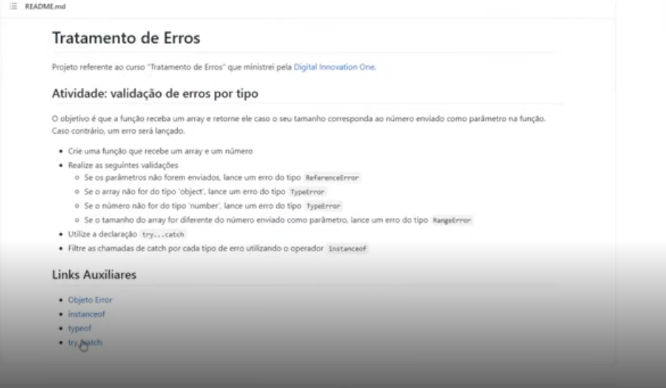

<https://developer.mozilla.org/pt-BR/docs/Web/JavaScript/Reference/Global_Objects/Error>

<https://developer.mozilla.org/pt-BR/docs/Web/JavaScript/Reference/Operators/instanceof>

<https://developer.mozilla.org/pt-BR/docs/Web/JavaScript/Reference/Operators/typeof>

<https://developer.mozilla.org/pt-BR/docs/Web/JavaScript/Reference/Statements/try...catch>

